Pivot Attendance Solutions (PAS)

Unlearning Attendance Summit
  - Executive Summary Recap

TABLE OF CONTENTS
Introduction 3
1. Executive Summary 3
2. Keynote Opening Speaker - Kearney 3
3. Discussant Keynote - Gottfried 3
4. Discussant Keynote - Ansari 3
5. Discussant Keynote - Keppens 3
6. Closing Keynote - Chang 3
Where to next 3
Appendix 3

See Condensed VIDEO Summary of the 2021 Unlearning Attendance Summit HERE
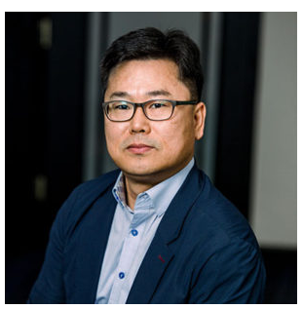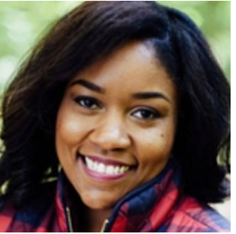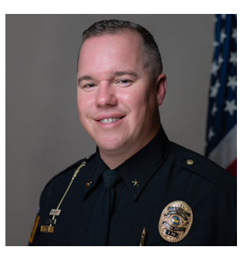
Meet our Board
Visit link: https://mypas.us/meet-our-founders-advisors-and-consultants/)
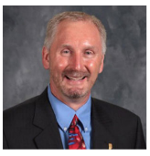
On behalf of the Advisory Board for Pivot Attendance Solutions, thank you for supporting the 2021 Summit.

As a proud advisory members and the Executive Director of the Indiana Principals Association it's my honor to invite you to engage with us on a topic PAS has spent, decades collectively researching, investigating, prosecuting, and educating to make long-term improvements...Attendance and Absenteeism.

A topic which undergirds our entire economy and social system for the type, amount, and quality of our workforce to the lives our students, where they live, how they feel, and how they are cared for.

It must respond to trauma, prevention, and education that matters for all. Any change we make must address not only those who are absent but those who are present, why they must be present, and why we need them to dream and learn.

##
PAS Board Welcome Message from Todd Bess

Introduction
Pivot Attendance Solutions (PAS)
Who We Are
Boasting over 50 years’ experience in perfecting a service driven model centered on students-systems-and attendance, Pivot Attendance Solutions (PAS) is your industry approved education and training consultants. PAS brings extensive knowledge and expertise in legal understanding of the state statues and policies, state data collection, advocacy, community-partnerships, university-based partnerships, homelessness for students in education, research on student bonding and school climate, truancy and absenteeism, defining terminology assessment of emerging models for evidence-based practices, and responding to students and community needs with resources. Exemplified through experience in the establishment of state and international groups on truancy and attendance, creating partnerships with leading state agencies, co-leading state convenings with attention to young black men, school attendance officers, and resource/hearing officers, and developing tailored programs for school corporations to respond to education and support programs. Working at all system levels in education to affect change from non-profits, for-profits, governmental, state, national, and international, PAS is bound to offer solutions via training, videos, consultancy, and assessment and reporting to meet your educational needs. With knowledge in curriculum any program can be tailored.

What We Do
Our strength is in responding to school attendance problems via law, research, and community provider services. Our curriculum, the Pivot Attendance Model (Pivot AM) uses home-grown school-community resources matched with school and program data to find solutions to attendance challenges. The Pivot AM curriculum was developed in 2016 and has had proven success in reducing suspensions and expulsions, increasing student attendance and completions, diversifying programs to demonstrate value of presence, increasing co-curricular community supports, influencing district policies, and emphasizing partnership in paying for whole-child education and citizenship.

Meet our Founders

Our Founder
Pivot Attendance solutions is an Indiana based education-focused organization designed to be an intermediary between the community and the entities serving school children. Many entities are responding to education from varied positions there has to be at least one entity piecing the puzzle together to ensure full-service, whole-child, trauma-informed, research grounded, relationship driven outcomes are possible for all students, their families and communities. The state cannot do it alone. Education partnerships must be formed for the long-term economic viability of our state. The goal then is to help the state respond to absenteeism. A long-term mission and vision of founder, Dr. Carolyn Gentle-Genitty. A visionary leader and legend in her own right, receiving accolades of Change Agent World Leader Award from the International Association for Truancy and Dropout organization, and Martin Luther King Bridge Builder Award 2021 and Inspirational Woman of the year award 2018 from Indiana University, her work in the field is well-known. Her work with adolescence has taken her from leading a YMCA as an Executive Director, writing assessment and training curriculum for UNICEF to writing policy and chairing boards focused on youth at-risk and entrepreneurship to national CARICOM research consultant conducting assessments with her school bonding instrument in Caribbean countries. She has written workplace curriculum and lead grant efforts to help at-risk students and their parents gain workplace skills with OAS (Organization of American States) and countless local organizations.

Our Lead Consultants
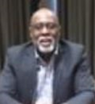
Kristen Martin, JD
James Taylor, MSW
Carolyn Gentle-Genitty, PhD

Executive Summary
Welcome to Indiana’s 2021 Virtual Summit on Unlearning Attendance! Glad you too believe in our shared response to reassess the baseline and value of education for our children. Pivot Attendance Solutions (PAS) is Indiana’s only grassroots research and school-state collaborative partner focused on School Attendance.
We must acknowledge that attendance tracks presence and absence but also engagement through systems and polices. Yes, 2020 was a traumatic year. The 2021-2022 academic year will bring many new COVID realities.
The state of Indiana has long made attendance a priority with over 50 statues governing discipline, behavior, reporting, and tracking. Statues are only guardrails to support local control corporations. Therefore unlearning attendance requires us to:
- Revisit decision making and problem-solving options
- Emphasize positive not punitive approaches;
- Define early detection and universal supports;
- Value prevention not reactionary consequences,
- Collect and use data that matters and informs, and
- Show care that begins with “what happened?”
As the state releases, its impact analysis and we make plans for training, educating, and receiving our children back into the classrooms.
We thank you for joining the summit to learn from national and international leaders on why innovation in attendance is integral to what we research, versus who and what gets tracked and learn of our call to action.
Enjoy the day prepared just for you. Thank you to all our partners and sponsors.
###

Message from Indiana Department of Education State Attendance Officer
What a year it has been. While we as a state are working on resuming education to what our new normal will look like. It is important that we examine lessons learned during the Covid pandemic. And it is important that we prepare to have our students come back, that we apply the knowledge and lessons learned along with blending empathy and right mindsets. Just as we have had a difficult year, so have many of our students.
As the view of attendance changes throughout the state, the nation, and internationally the role of the attendance officer is to …
- Provide customer service, legal interpretation of policy, case law, and broad decision.
- Interpret policy to mediate and help both the school and student figure out and solve the situation before the situation is amplified.
- Serving the community to help socially, emotionally, and behaviorally.
- Helping all children able to attend school
- Addressing the needs of the child.
- IDOE State Attendance Officer, Lisa Truitt
Role of State ATtendance Officer
We need to be prepared to engage with families discussing the value of education. When a student misses school, they miss a lot. We will have students who have experienced trauma, have experienced hardship and are in need of support, we will have students that haven’t been around others in a year and will need to relearn how to be in a school setting. It will be important to remember to approach our students with compassion, without judgement or making assumptions. I believe in taking a proactive approach in addressing the full needs of the whole child. The most effective strategy to improve school attendance is to engage with students and families. We know that when a school community offers a warm, welcoming, and safe environment, attendance improves. Knowing that when a school emphasizes building relationships and including families in their communication, attendance improves. Knowing that a student’s educational environment notices when they miss school, attendance improves. It’s all about relationships.
Every single opportunity counts with our students and families. Connection is our ability to take the perspective of others and develop empathy. So what direction are we headed as a state? I believe in using a positive and proactive tiered response to student attendance, focused on chronic absenteeism. I urge all schools to have a tiered approach using frequent data monitoring to guide, and address chronic absences. Make yourselves aware of the support and resources available in your area. Rather, let's take a look at our policies and procedures, to help create a system that helps students and families, and builds relationships between the school and the community it serves. We need to prioritize connection over compliance. It's time to review policies that keep students out of school, like exclusionary discipline, and find better ways to keep our students in school actively engaged.
In closing, I'd like to charge Indiana educators and policy makers with the following:
- Make chronic absence a priority and identify contributing factors in your school.
- Include strategies to reduce chronic absence and improve attendance in school improvement plans.
- Support sharing data with health, social service agencies, city and county government, and local school safety commissions.
- Seek grants for attendance tracking, and chronic absence reduction.
- Build public awareness and consensus about addressing chronic abuse.
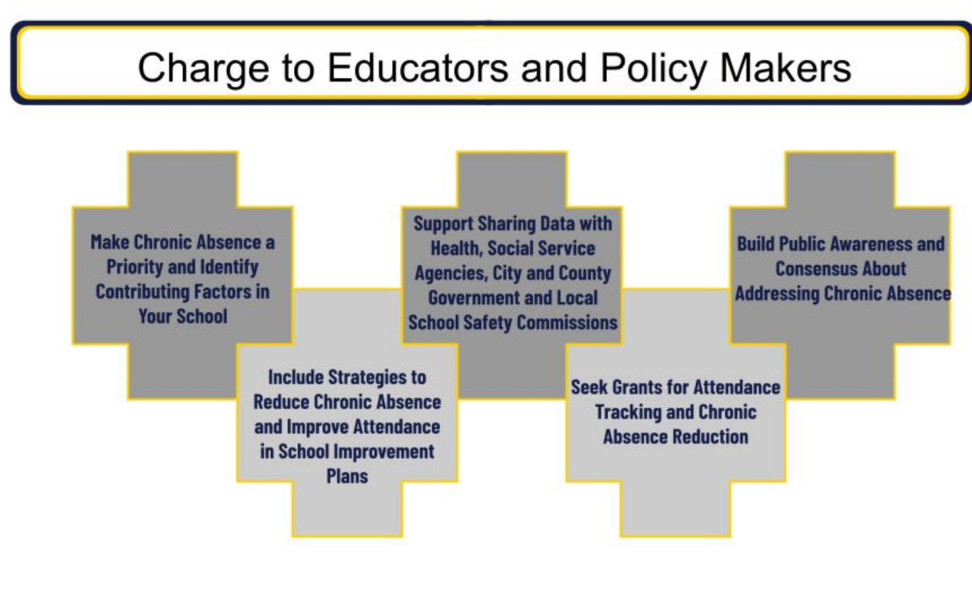

opening KEYNOTE - Kearney
Dr. Christopher Kearney | Background: One of the United States most cited researchers and translational research in absenteeism and school attendance problems is Dr. Christopher Kearney, Distinguished professor, Chair of Psychology at the University of Nevada, Las Vegas, and Director of the UNLV Child School Refusal and Anxiety Disorders Clinic. Most notable known for his work in the development of the Multi-tiered Systems of Support (MTSS) Approach and Response to Intervention (RTI), Dr. Kearney is a clinical child psychologist who specializes in internalizing problems in youth, with particular emphasis on (1) problematic absenteeism and school refusal behavior, (2) post-traumatic disorder among maltreated and otherwise traumatized youths, (3) selective mutism, and (4) assessment and other anxiety-related problems such as perfectionism in children. Dr. Kearney is highly active in publishing with his graduate students, provides many resources to clinicians and lay persons regarding his assessment and treatment protocols, and commonly conducts training workshops for professional groups and school districts. His latest work redefines the need to enhance synergy regarding school attendance/problems via shared conceptual schemas, cohesive organization of key variables, fundamental evolutionary processes, assimilated measurement tools, and coordinated intercession strategies. In sum, we must be systemic defining core constructs, shared domain architectures and ecological factors with, nuanced early warning systems, and data mining algorithms for appropriate evaluation and assessment in order for the multi-tiered systems of support to work well for broad and specific interventions. Problematic school absenteeism, selective mutism, post-traumatic stress disorder in maltreated children, and other internalizing disorders. My research focuses on assessment and treatment issues as well as taxonomy.
This section gives a brief summary of the hallmark points from Keynote Speaker Dr. Christopher Kearney’s presentation. University of Las Vegas | chris.kearney@unlv.edu
- Tectonic shifts in education
- COVID-19 pandemic: What is school attendance? Will some children never come back to school? What supports and instructional spectra will be needed?
- Renewed focus on social justice issues: Key disparities in school funding/closures, exclusionary discipline, health promotion and access to care, housing/food insecurity, barriers to attendance
- Fracturing of society, anti-science movement, and loss of faith in key institutions: Polls indicate most millennials believe the educational process does not help people succeed; parents less satisfied with K-12 education; decline in college enrollment 7 times greater for males than females
2 Unlearning evaluation/assessment
- Develop nuanced early warning systems and data mining algorithms to blend evaluation and assessment
- Examine large-scale data sets in more targeted ways to identify key root causes and patterns of school absenteeism in a particular community, school, or group of students
- Allow for more accurate educational policies tailored to unique local conditions and student/family circumstances
- Algorithm-based and model-based efforts
- Deitrick and colleagues’ (2015) CART analysis in Pittsburgh: changing schools during an academic year and housing structure were primary factors with respect to chronic absenteeism there; local educational policy was modified to focus more specifically on immediate issues such as new school assignments, stabilization of housing opportunities and conditions, aligning public and school transportation options, improving safety conditions during transportation to school, training crossing guards in mentoring, and providing more timely bus assignments
3 MTSS blueprint for re-opening schools in the OVID-19 era
Unlearning implementation
- Multi-agency collaboration (e.g., to share information to track students, integrate housing and attendance policies) to address a wickedly complex problem
- Avoid a deficit/reductionistic approach
- Attend to particularly salient drivers of absenteeism/focus on disaggregated data, intersectionality, and localized root cause analysis
- Cultural responsiveness
- Change in focus from absenteeism to attendance data to move toward positive policies and democratic and empowering structures to support school reengagement
References
Childs, J., & Lofton, R. (2021). Masking attendance: How education policy distracts from the
wicked problem(s) of chronic absenteeism. Educational Policy, 35, 213-234.
https://doi.org/10.1177/0895904820986771
Deitrick, S., Ye, F., Childs, J., & Zhang, C. (2015). Connecting people and place – Improving
communities through integrated data systems: Chronic school absenteeism in public schools in Pittsburgh, PA. University of Pittsburgh: University Center for Social and Urban Research.
Gentle-Genitty, C., Taylor, J., & Renguette, C. (2020). A change in the frame: From absenteeism
to attendance. Frontiers In Education, 4. 10.3389/feduc.2019.00161.
Graczyk, P., & Kearney, C.A. (2021). Implementing a multi-dimensional, multi-tiered system of
supports framework to promote school attendance and address school attendance problems. Manuscript in preparation.

###

Discussant KEynote - Ansari
Dr. Arya Ansari | Background: Arya Ansari is an assistant professor of Human Development and Family Science in the College of Education and Human Ecology and a faculty associate at the Crane Center for Early Childhood Research and Policy. His research program investigates how contextual factors influence the early development of low-income and minority children, with the aim of intervening and informing policies that can minimize the opportunity gap in the United States.
This section gives a brief summary of the hallmark points from Discussant Keynote Speaker Dr. Arya Ansari | The Ohio University | ansari.81@osu.edu
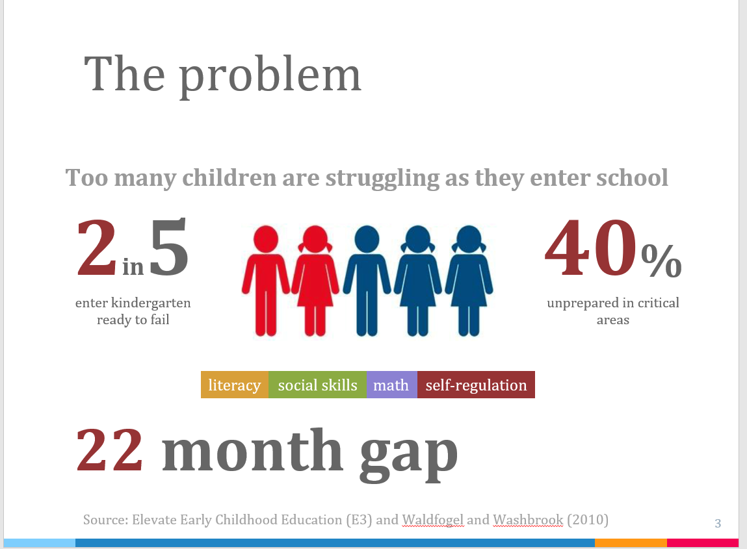
- Absent from the Start: A Snapshot of Preschool Absenteeism
- 2 million children attended preschool; 51% of children below 200% of the federal poverty line attended preschool. 66% of children of those above the 200% of the federal poverty line (FPL) attended preschool. There is a preschool achievement gap.
- Preschool education minimizes the achievement at kindergarten entry between those at 35% of the FPL and those at 185% of the FPL by roughly 50-60%. The long-term potential is they are less likely to have multiple arrests, more likely to be employed, more likely to own a home and more likely to earn more money.
- 8-9 is the average number of days missed among preschoolers. 22 percent of preschoolers are chronically absent with estimates ranging from 10-35 percent. As a point of contrast, nationally kindergarten and first graders are chronically absent at a rate of 10-11 percent. All it takes for a child to be chronically absent is 2 absences per month. Data is very limited.

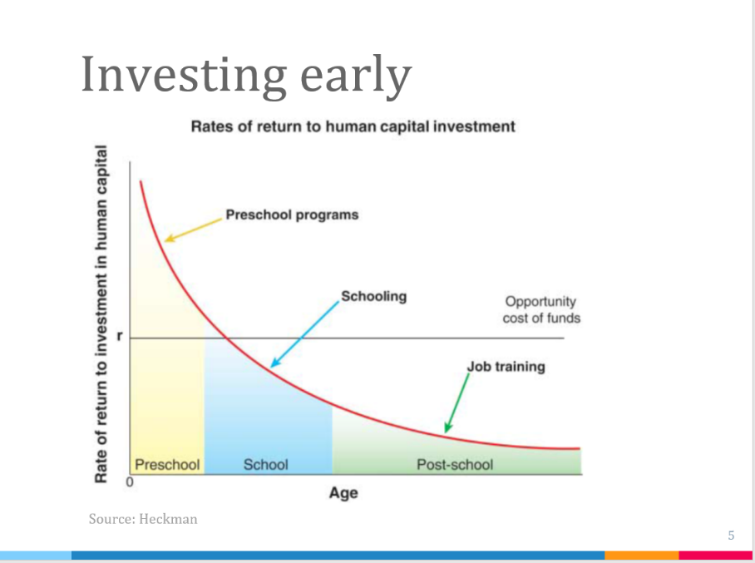
- Early absenteeism is one of the strongest predictors of later absenteeism.

Why are children absent from preschool?

  - Family circumstances and necessity
  - Family stress and routines – families that experience greater stress and instability may be associated with greater absenteeism

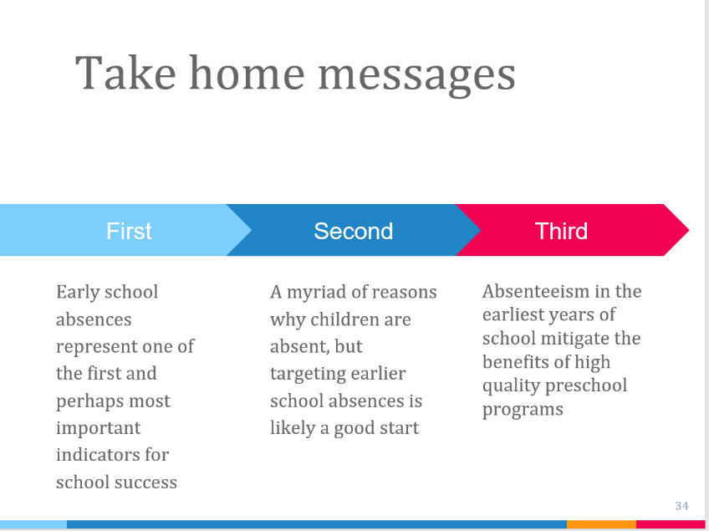
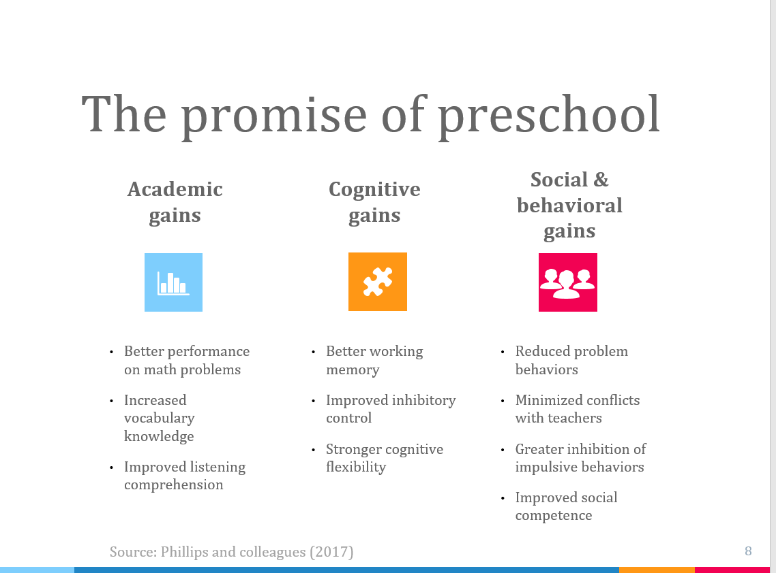

###

Discussant KEynote - Gottfried
Dr. Michael Gottfried | Background: Founder of the Education Policy Collaborative, a forum for education policy scholars from across the United States to impact both scholarship and public policy. A nationally renowned education economist, Dr. Michael Gottfried’s work focuses on the economics of education (career ad technical education, student with disabilities, and absenteeism) and the use of economics for decision making and policy. He grapples with why we need to do things differently especially coming out of the pandemic and who can make the most change. He aims to boost academic and other student outcomes by examining which policies, practices, and contexts promote or block their success. In recent work he has examined whether new teachers are prepared to address absenteeism in their classrooms. He has also explored whether implementing new forms of school breakfast programs, such as in the classroom rather than in the cafeteria, can impact students’ absenteeism and achievement. Finally, he is studying whether students with disabilities have stronger high school and college outcomes when they take math/science career and technical education courses. As well-funded and published research scholar with support from the Institute of Education Sciences, National Science Foundation, National Institutes of Health, Spencer Foundation, Foundation for Child Development, American Educational Research Association, and many other organizations, he sought after and called to speak to this research in presentations in on journal editing boards such as in leading journals like that of Educational Evaluation and Policy Analysis, American Educational Research Journal, and Teachers College Record.
This section gives a brief summary of the hallmark points from Discussant Keynote Speaker Dr. Michael Gottfried |University of Pennsylvania | mgottfr2@upenn.edu
- Reframing the Research – Focusing on Schools, Not the Students
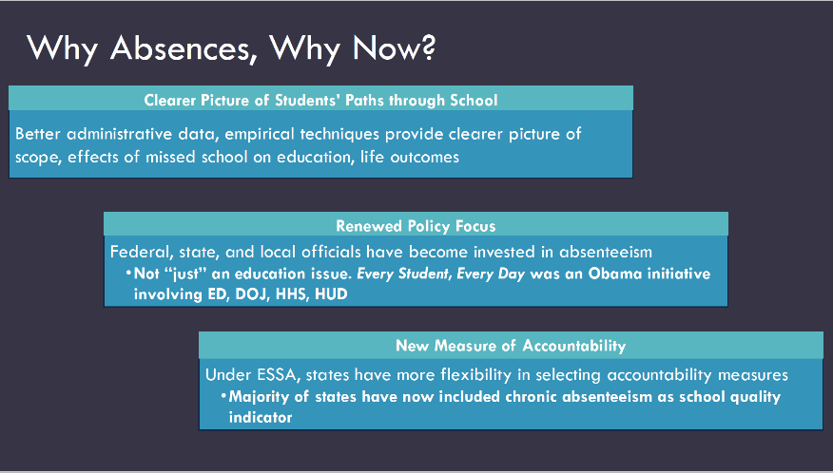
  - For accountability to be successful we must assume:
    - That states and districts can develop robust systems for accurately tracking student attendance
    - That researchers can develop fair measures assessing schools on attendance metrics; and that
    - Schools can affect absenteeism
      - This is a misconception because many factors associated with attendance is beyond the school’s control
      - Vectors of intervention are not easy to identify
      - One solution or best practice for one school or district can be hard to scale, replicate and/or sustain
  - What Current or Ongoing school-specific contexts might be contributing to absence reduction?
    - School context matters
      - Case study – the context of special education inclusion
      - Nationally 63% of Students with Disabilities (SWDs) are educated in traditional classrooms in 2014; In NYC, 61% of SWDs are educated in traditional classrooms in 2014
      - Estimates suggest that absenteeism is higher for SWDs – SWDs in Elementary are 50% more likely to be chronically absent and HS Freshman had 50% more absences (Cortiella & Horowitz, 2014)
    - Everyone is focused on the student but that student characteristic is malleable
    - Does the “where” in learning in traditional schools affect absenteeism
      - Focus on the experience of the SWD – this helps to identify factors that are manipulable and helps to prioritize which contextual factors that can be addressed

###

Dr. Gil Keppens | Background: A leading research in using design, data-collection, analysis, and valorization of qualitative and large-scale quantitative research to study absenteeism and truancy, Dr. Keppens is internally credited with work on examining partial absences and calling for change in measuring absenteeism. As a researcher fellow at Research Group TOR via the University of he actively engages in truancy, youth, sociology of education, and educational policy research. He believe that to use attendance monitoring within an integrative strategy for preventing, assessing and addressing cases of youth with school absenteeism, we need to know whether the attendance data collected by schools cover all students with (emerging) school attendance problems (SAP). Dr. Keppens serves as Vice President of the International Network for School Attendance, where he leads the scientific committee on defining what research is need in the area of absenteeism world-wide.
This section gives a brief summary of the hallmark points from Discussant Keynote Speaker Dr. Gil Keppens | Vrije Universiteit Brussel| Gil.Keppens@vub.be
- Mismatch between Policy and Practice
  - School absenteeism is a serious problem among youth and has been high on the political agenda with interventions on the national and local levels, yet school absenteeism remains high
  - We need to unlearn the way we use our attendance data – at the present time in most countries, attendance data is used at the tier one level and is largely an administrative task. This data should be utilized to evaluate interventions at the tier 1, 2 and 3 levels.
  - There are big differences in absenteeism severity and there are many risk factors for school absenteeism that is not limited to the individual child but also relate to the family, peers, the school environment/culture and the community
  - There are very different pathways to school attendance problems making it very difficult to predict and intervene
- In 2016, Dr. Keppens conducted a research study in Belgium and discovered that most students when absent unexcused from school were absent with the knowledge of their parent, stayed at home, often alone and were never caught.
- The Importance of School bonding
  - School bonding is the strength of the relationship between a student and school (peers, teachers, school environment)
  - Interventions based on the principals of increasing school bonding have been more effective in improving school absenteeism
    - Interventions are never on the absenteeism itself, rather the underlying causes
    - Schools should use a long term perspective – start working on building and strengthening a school bond early in a school career
    - Primarily focus on student completion
- The Power of School Attendance Data – Helpful Tips
  - Implementing a system of detective and intervention is a work in progress – expect a short term increase in absenteeism numbers at first
  - Implement interventions at all levels
  - Invest in School/Community Collaborations to address the underlying causes of absenteeism
  - Adjust the Registration and Detection policies between schools
  - Appoint a local coordinator

closing keynote - Chang
Executive Director Hedy Chang | Background: Attendance Works is an action research project, moving vertically from local environments to national policy-making. Working in over two-dozen school districts, 32 states and in collaboration with 70 national organizations, Attendance Works uses continuous quality improvement to evaluate gaps in knowledge and capacity building. Constant assessment of interventions leads to updated and new tools and approaches in reducing chronic absence. Hedy Chang was named by the White House as a Champion of Change for her commitment to furthering African American Education, hand-picked by the Vice President of the Annie E. Casey Foundation, to examine whether missing too much school in the early grades was one of the reasons so few low-income children were reading proficiently by the end of 3rd grade. The answer was yes, chronically absent students—those who miss 10 percent or nearly a month of school—do worse academically. Subsequently coining the term “chronic absence” to differentiate it from truancy and to account for all absences, including excused and unexcused. Once defined, Attendance Works focused local communities, school districts, teachers, and policy-makers on collecting and analyzing data on chronic absence. The next step was urging the use of this information to forge partnerships with families, civic organizations and public agencies to unpack and address common barriers to getting to school, such as lack of access to health care, a safe path to school or bullying, and nurturing a community wide culture of daily attendance in schools. Hedy Nai-Lin Chang directs Attendance Works. She is deeply committed, a known scholar on chronic Absence in the Early Grades and called upon nationally and internationally to speak to the topic of attendance.
This section gives a brief summary of the hallmark points from Closing Keynote Speaker Hedy Chang | AttendanceWorks | hedy@attendanceworks.org
- Monitoring Chronic Absenteeism: Why it matters for COVID Recovery
Chronic absence is missing so much school for any reason that a student is academically at risk. This metric is typically defined as missing 10% or more of school for any reason. If you use this as a metric, this is a useful early intervention tool.

- Challenges that existed before have been exacerbated by the pandemic – has substantially increased barriers to student attendance
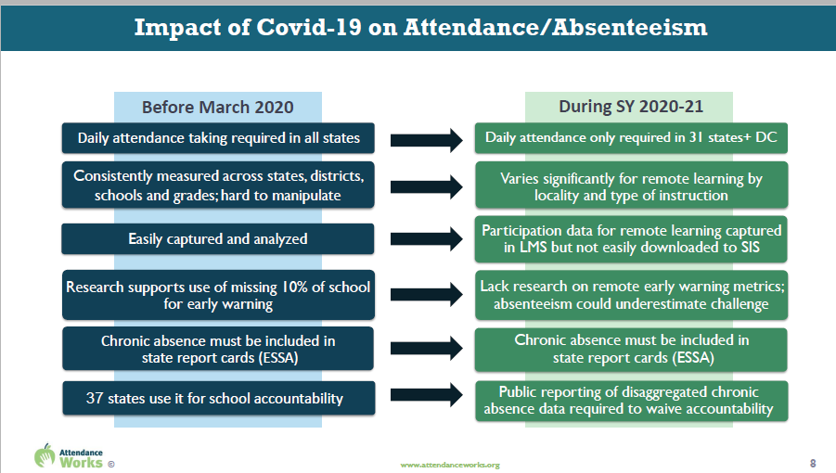
  - Before March 2020, daily attendance taking was required in all 50 states and was consistently measured across states, districts, schools and grades. Data was easily captured and analyzed. Research supported the use of chronically absent as a early warning sign for attendance intervention. 37 states use attendance for school accountability.

  - During the 2020-2021 school year (Covid year), daily attendance was only required in 31 states and Washington DC and varied significantly for remote learning by locality and type of instruction delivered. Participation data for remote learning was captured in LMS but not easily downloaded to SIS. Currently, there is a lack of research on remote learning early warning metrics. School must publicly report disaggregated chronic absence data in order to waive accountability for the year.
  - The one factor that remained constant is that chronic absence must be included in state report cards (ESSA).

- Reducing chronic absence can help close equity gaps
  - Poor children are four times more likely to be chronically absent in Kindergarten than their higher income peers
  - Children in poverty are more likely to lack basic health and safety supports that ensure a child is more likely to get to school
  - The adverse impact of absenteeism on literacy development is 75% greater for these children than for their middle class peers
- Effective solutions require understanding what factors contribute to chronic absence
  - Understand barriers to regular attendance
    - Chronic and acute illness
    - Family responsibilities or home situation
    - Trauma
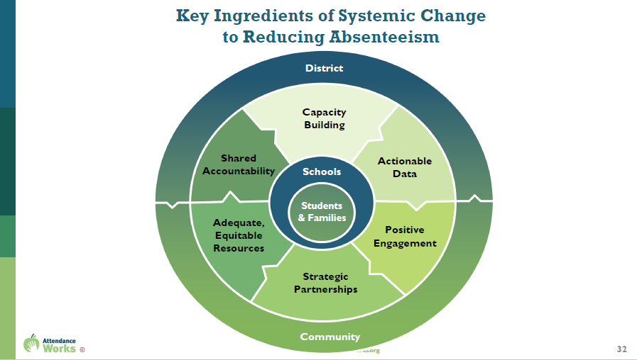
    - Poor transportation
    - Housing and/or food insecurity
    - Inequitable access to needed services
    - System involvement i.e. DCS and/or Probation
  - School aversion
    - Struggling academically and/or behaviorally
    - Unwelcoming school climate
    - Social and peer challenges
    - Biased disciplinary and suspension practices
    - Undiagnosed disability and/or disability accommodations
    - Negative parental attitudes about education
  - Student Disengagement
    - Lack of challenging, culturally responsive instruction
    - Bored
    - No meaningful relationships to adults in the school
    - Lack of enrichment opportunities
    - Lack of academic and behavioral support
    - Failure to earn credits
  - School/Administrative Misconceptions
    - Absences are only a problem if they are unexcused
    - Missing 2 days per month doesn’t affect learning
    - Sporadic absences aren’t a problem
    - Attendance only matters in the older grades
    - Suspensions don’t count as an absence

###

Thank you to all …
partners, presenters, and participants.

Appendix
Partner Resources
- Children Bureau
- Children’s Policy and Law Initiative of Indiana, CPLI
- Department of Children Services, DCS
- Eskenazi Indy Heartbeat
- Fight for Life Foundation
- Indiana Department of Education, IDOE
- Indiana University School of Education, IU SOE
- Indiana University School of Social Work, IUSSW
- Mental Health Association of Indiana, MHAI
- MSD of Warren Township
- Reach for Youth

Pivot Attendance Solutions - PAS - https://mypas.us/

Pivot Reads
- Gentle-Genitty, C., & Taylor, J. (2021). Responsibility for socialization - Truancy: More than absences. Pivot Attendance Solutions. https://doi.org/10.7912/vhe8-fd69

- Gentle-Genitty, C., Taylor, J., & Martin, K. (2021). Attendance CARE analysis. Pivot Attendance Solutions. https://doi.org/10.7912/FYGK-ZS09

- Martin, K., Taylor, J., & Gentle-Genitty, C. (2021). Resolving Truancy through Community Collaboration. Pivot Attendance Solutions. https://doi.org/10.7912/JB9D-K250

- Gentle-Genitty, C., Taylor, J., & Martin, K. (2021). Absenteeism: School mental health: Define, spot, and deploy. Pivot Attendance Solutions. https://doi.org/10.7912/R43M-DK55

- Taylor, J., Gentle-Genitty, C., & Martin, K. (2021). Indiana Attendance Law. Pivot Attendance Solutions. https://doi.org/10.7912/4H40-TS80

- Taylor, J., Gentle-Genitty, C., & Martin, K. (2021). Mental is health in school. Pivot Attendance Solutions. https://doi.org/10.7912/YT6K-PM25

